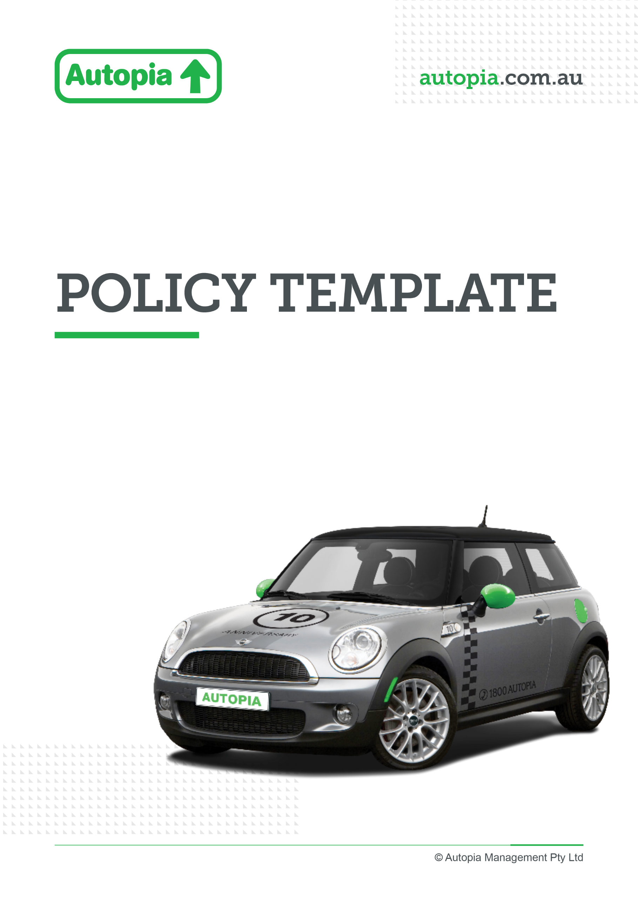

Employer resource

Careers pages and job ad

Careers page
Including novated leasing on your careers page helps position your organisation as one that offers meaningful, practical benefits that support employees’ financial wellbeing and lifestyle. By highlighting your partnership with Autopia in your careers page, you make it clear to candidates and new hires that they can access a smarter, more flexible way to manage the cost of a vehicle—potentially increasing their take-home pay and simplifying everyday expenses.
Featuring this benefit upfront strengthens your employee value proposition, differentiates you in a competitive talent market, and encourages prospective employees to see the tangible value of joining your organisation from day one.

Website careers page copy option 1
Drive more from your salary with novated leasing
As part of our employee benefits, you can access novated leasing through Autopia—helping you save on a new or used car by paying through your pre-tax salary, potentially reducing your taxable income while simplifying the cost of running your vehicle.

Website careers page copy option 2
Novated Leasing – A smarter way to drive
We’re committed to helping our people make the most of their salary and lifestyle benefits. That’s why we offer access to novated leasing through Autopia.
Novated leasing allows you to bundle the cost of your car and running expenses—like fuel, servicing, insurance and registration—into one regular payment taken from your pre-tax salary. This can reduce your taxable income and make budgeting easier, all while giving you access to the car you want.
With expert support from Autopia, you’ll be guided through every step—from selecting a vehicle to managing your lease—making the process simple and seamless.

Website careers page copy option 3
More choice, more flexibility, more value
As part of our commitment to supporting your financial wellbeing, we offer novated leasing through Autopia as part of our employee value proposition.
This benefit gives you a flexible and tax-effective way to finance your car, with payments made through your salary. By combining vehicle and running costs into one structured arrangement, you can:
- Potentially reduce your taxable income
- Enjoy predictable, easy-to-manage payments
- Access competitive pricing on vehicles and running costs
- Choose a car that suits your lifestyle, including electric and hybrid options
It’s just one of the ways we help you get more value from your employment with us.

JOB AD
We have provided text that can be included in your job advertisements to showcase your employee benefits.

Job ad copy
We offer novated leasing through Autopia, giving eligible employees a convenient and tax-effective way to finance and run a vehicle using their pre-tax salary. It’s a simple, flexible benefit designed to help you save on car costs while enjoying greater choice and convenience.

