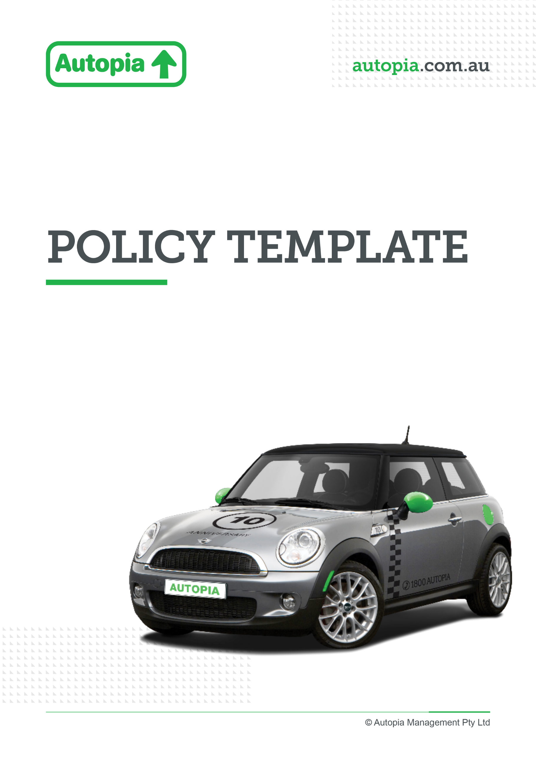

Employer resource

Intranet copy

Promoting Autopia partnership through your employee IntrANet
To support the rollout of novated leasing with Autopia, we’ve provided ready-to-use intranet content that you can publish internally to introduce and promote this benefit to your employees.
Why this intranet content matters
The intranet page acts as your central source of truth for novated leasing. While emails and Viva Engage posts create awareness, the intranet content provides the detail employees need to understand and take action.
Specifically, it is designed to:
- Educate employees on how novated leasing works in a simple, accessible way
- Clearly explain the value and potential savings
- Highlight key opportunities such as electric vehicle benefits
- Provide direct pathways to action (quotes, consultations, webinars)

By giving employees a single destination for information, you reduce confusion and make it easier for them to engage with the benefit.

How to use the content
We recommend positioning this intranet page as the anchor for your internal communications, and using it alongside other communications:
1. Publish as a feature article
- Upload the content to your intranet under Employee Benefits / Rewards
- Include Autopia branding and imagery where possible
- Add custom links (booking, quotes, webinars)
2. Link to it from all communications
Use this page as the destination in:
- Viva Engage posts
- Employee emails
- HR or onboarding communications
3. Keep it visible
- Pin or feature the article on your intranet homepage
- Include it in new starter materials as an ongoing benefit

Intranet copy

Take advantage of novated leasing with Autopia
We’re excited to partner with Autopia to offer novated leasing as part of your employee benefits.
Get started today
- 📞 Book a call back: Book a consultation
- 🎓 Attend a webinar: Electric Vehicle Webinar | Autopia
- 💻 Get a quote online: Novated Leasing & Car Salary Packaging with Autopia
- ☎️ Speak to an Autopia specialist: 1800 288 674

Why consider a novated lease?
A novated lease with Autopia is one of the simplest and most cost-effective ways to buy and run a car—and you don’t need to be on a high income to benefit.
With a novated lease, your car and most running costs are paid through your salary, which may help reduce your taxable income and improve your take-home pay.

You could save thousands
Save when you buy
- Pay no GST on the purchase price of the car (up to applicable limits)
- Benefit from Autopia’s buying power and dealer network to secure competitive pricing
Save when you drive
- Bundle fuel/charging, registration, insurance, servicing and tyres
- Pay using a mix of pre-tax and post-tax salary, which could reduce costs
Save time and simplify your finances
- One regular payment deducted from your pay
- No need to manage multiple bills and expenses

Thinking about an electric vehicle (EV)?
Electric vehicles are becoming an increasingly popular option—and a novated lease can make them even more accessible.
Why EVs are worth considering:
- Lower running and maintenance costs
- Convenient home charging
- Reduced environmental impact
Additional savings opportunities
Under the Federal Government’s Electric Car Discount, eligible EVs may be exempt from Fringe Benefits Tax (FBT) when purchased through a novated lease.
This can significantly reduce the overall cost compared to a petrol or diesel vehicle.
Eligibility criteria apply, including vehicle value thresholds and registration requirements.
👉 Find out more > Novated Leasing & Car Salary Packaging with Autopia

Compare cars and get a quote anytime
Autopia makes it easy to explore your options online:
- Compare different vehicles, features and pricing
- View an easy-to-understand breakdown of costs per pay cycle
- See estimated tax savings over the life of the lease
- No obligation to proceed
👉 Start your quote > Novated Leasing & Car Salary Packaging with Autopia

Want to learn more?
Autopia offers a range of ways to help you make an informed decision:
- 📞 Book a one-on-one consultation
- 🎓 Join a live webinar
- 💻 Explore tools and calculators online
👉 Get started today > Novated Leasing & Car Salary Packaging with Autopia

Start exploring today
A novated lease could help you:
- Save money
- Simplify how you manage your car expenses
- Access a car that suits your lifestyle
👉 Take the next step > Novated Leasing & Car Salary Packaging with Autopia

Important information
Before entering into a novated leasing arrangement, you should consider your personal financial situation and seek independent advice where appropriate. Eligibility criteria, terms, and conditions apply.

