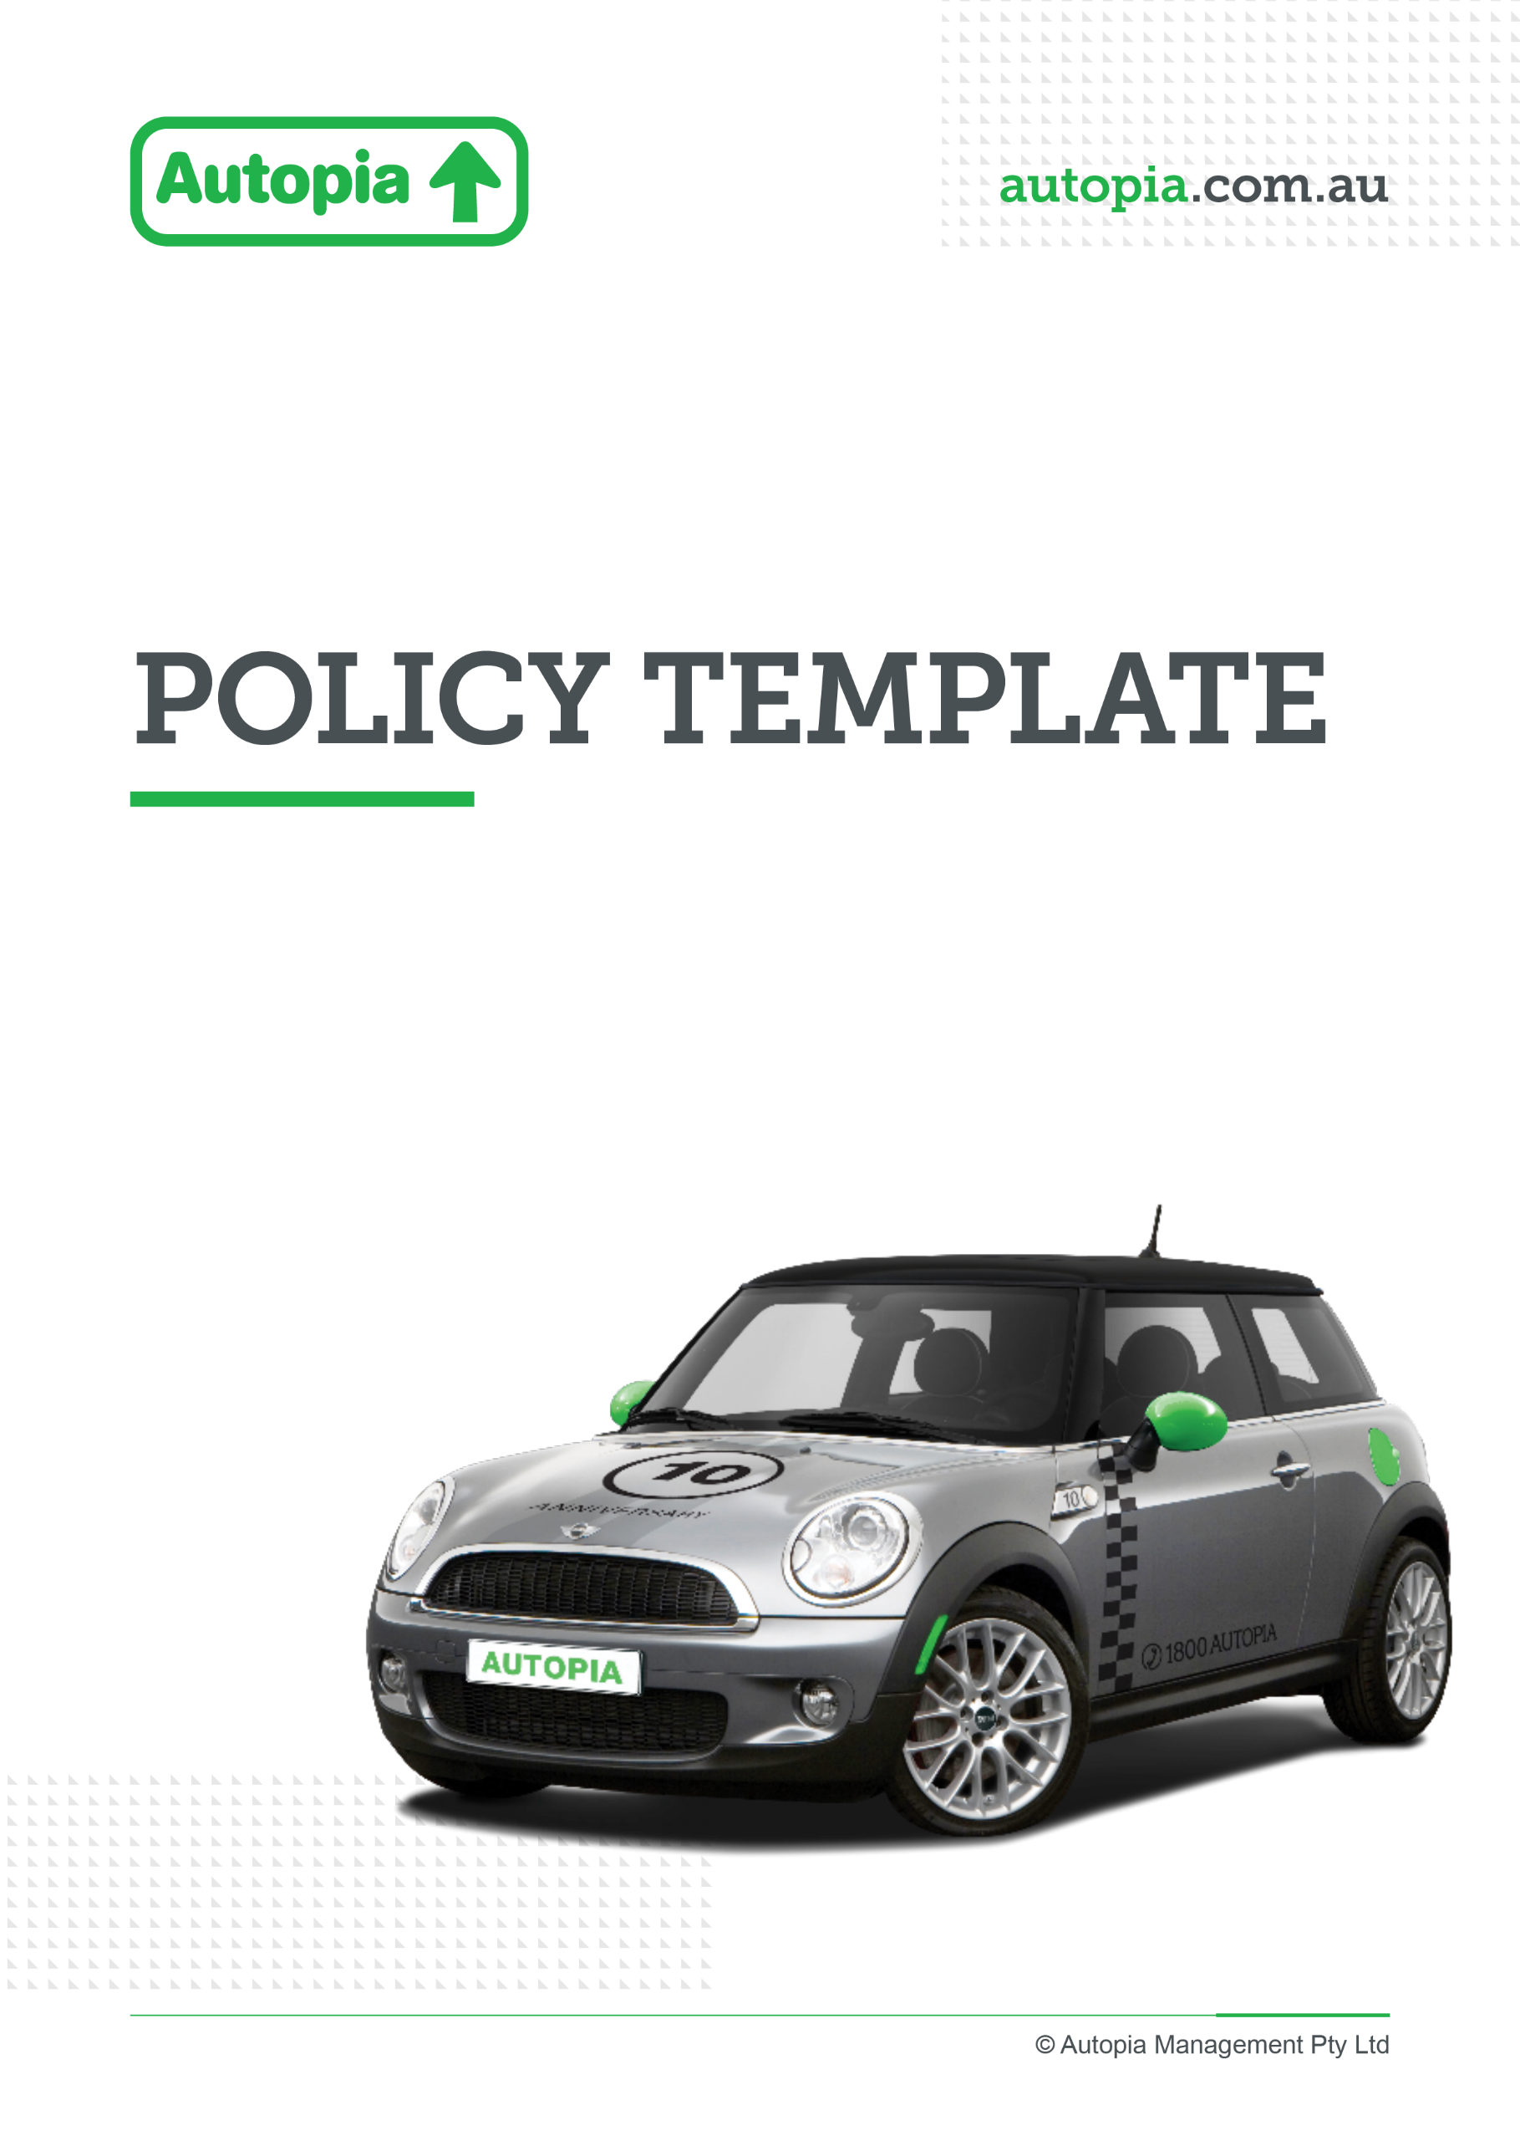

Employer resource

Launch email

Promoting Autopia partnership through all staff employee launch email

To support the launch of your new partnership with Autopia, we’ve provided a ready-to-use employee launch email that you can send to your workforce.

Why use this email
The launch email is designed to introduce the benefit clearly and simply, helping employees understand what novated leasing is, why it’s valuable, and how they can get started. It plays a critical role in creating initial awareness and interest, and sets the foundation for ongoing engagement through your broader campaign.

How to use it
We recommend sending this email as your first communication to employees, supported by links to your intranet page and Autopia resources. You can further personalise it by adding your organisation’s branding, links, and key contacts.
For best results:
- Send it from a recognisable internal sender (e.g. HR or People & Culture)
- Include clear links to book consultations, access quotes, or learn more
- Follow up with Viva Engage posts or articles in employees newsletters and reminders to reinforce the message

Used effectively, this email will help ensure employees are aware of the benefit, understand the value, and feel confident taking the next step.

Launch email
Hi Team,
We’re pleased to let you know that we’ve partnered with Autopia to introduce a new employee benefit—novated leasing.
This is a simple and flexible way to buy and run a car using your salary, with the potential to save money and make managing your vehicle costs easier.
With a novated lease, your car and most running costs—like fuel or charging, registration, insurance and servicing—are bundled into one regular payment that comes from your salary. Because a portion of these costs may be paid from your pre-tax income, this can help reduce your taxable income and improve your take-home pay.
There are a number of advantages to consider. Many employees find it a cost-effective way to own and run a car, as GST is not applied to the purchase price (within applicable limits) and ongoing costs are simplified into a single, regular deduction. You’ll also have access to Autopia specialists who can guide you through your options and help you choose a vehicle that suits your needs and lifestyle.
If you’ve been thinking about an electric vehicle, this could also be a great time to explore it. Eligible EVs may be exempt from Fringe Benefits Tax (FBT), which can make them even more affordable, in addition to their lower running and maintenance costs.
Getting started is easy. You can book a consultation with an Autopia specialist, request a personalised quote online, or join a webinar to learn more about how novated leasing works and whether it’s right for you.
Learn more and get started here
- 📞 Book a call back: Book a consultation
- 🎓 Attend a webinar: Electric Vehicle Webinar | Autopia
- 💻 Get a quote online: Novated Leasing & Car Salary Packaging with Autopia
- ☎️ Speak to an Autopia specialist: 1800 288 674

With the cost of living top of mind for many, novated leasing is a practical way to make your money go further while accessing a car that suits your needs.
If you’re curious, we encourage you to explore your options—there’s no obligation to proceed, and it’s a great way to understand what’s possible.
Kind regards,

Important information:
Novated leasing may not be suitable for everyone. Before making a decision, you should consider your personal circumstances and seek independent financial advice where appropriate.

