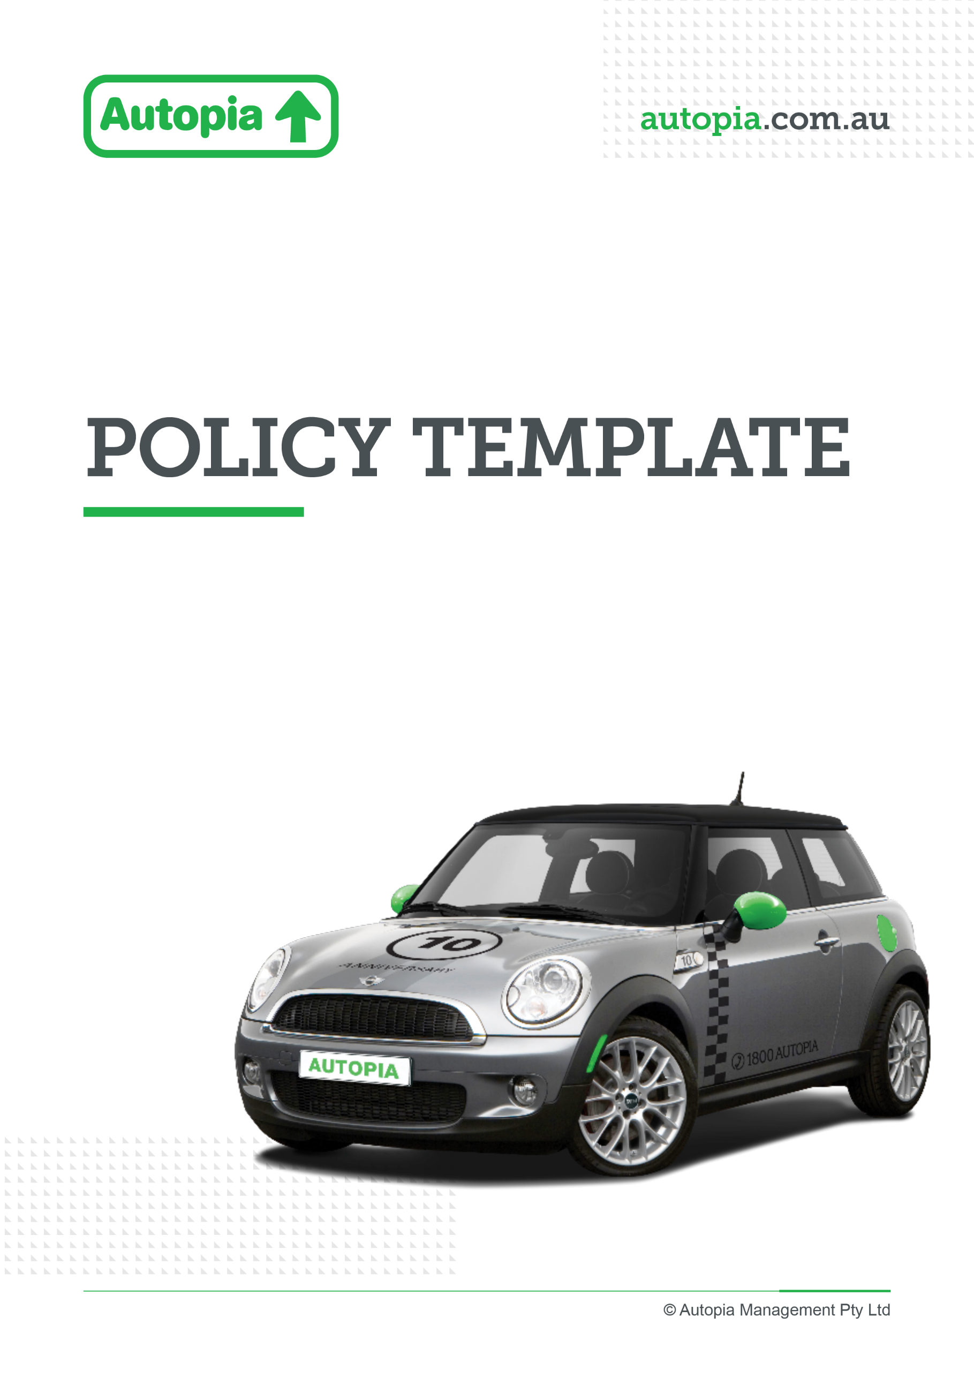

Employer resource

Viva Exchange posts

Promoting Autopia partnership through viva exchange
To support the launch of your new novated leasing benefit with Autopia, we’ve created a series of ready-to-use Viva Engage posts designed to help you effectively communicate this offering to your employees.
Why use these posts?
Introducing a new benefit is most successful when employees clearly understand what it is, how it works, and why it matters to them. These posts are designed to:
- Build awareness of the Autopia partnership and novated leasing
- Educate employees on how novated leasing works and potential benefits
- Drive action, encouraging employees to learn more, attend webinars, or book consultations
- Reinforce key messages over time through a structured campaign

By delivering consistent messaging across multiple touchpoints, you increase visibility and help employees feel confident engaging with the benefit.

How to use the posts
We recommend running these as part of internal communications, posting regularly on Viva Engage. Each post is designed to be:
- Easy to publish – simply copy, paste, and insert custom links
- Engaging – use of short, employee-friendly language
- Action-oriented – clear calls to action (e.g. book a consultation, join a webinar)

Tips to maximise engagement
To get the most impact from posts:
- Tag key stakeholders (e.g. HR, Payroll, Benefits team) to increase reach
- Include links to the Autopia booking page and other key pages
- Use visuals (images/videos) to improve engagement
- Pin key posts (such as the launch announcement) for visibility
- Encourage leaders to comment or share to amplify the message

Viva exchange posts
Below is a ready-to-use 10-post Viva Engage campaign tailored for an Autopia client announcing a new novated leasing partnership.

Post 1 – Launch Announcement (Image + Text)
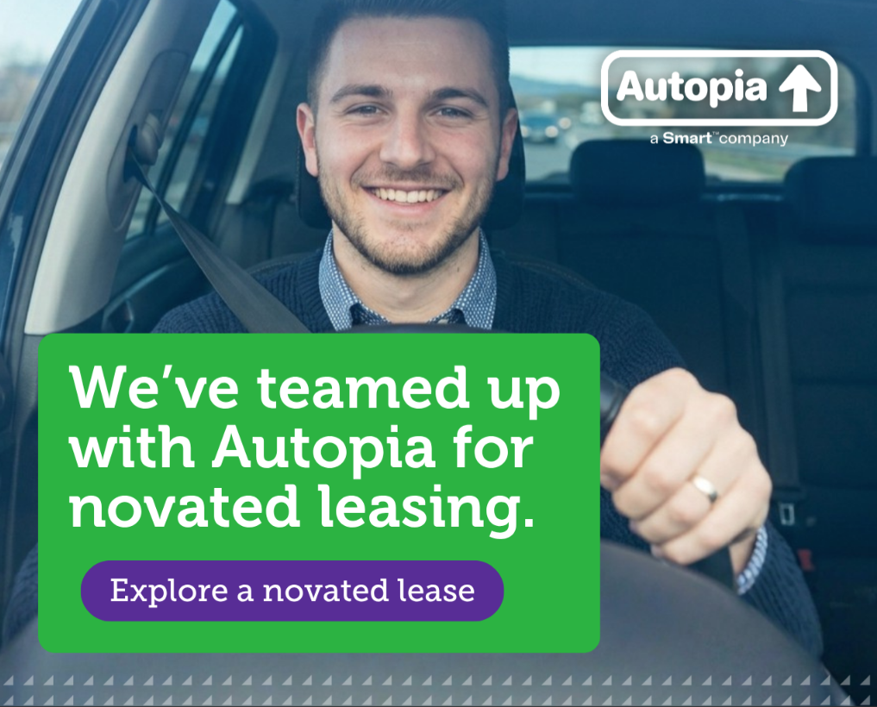
🚗 We’ve partnered with Autopia to bring you novated leasing!
We’re excited to introduce a new employee benefit—novated leasing with Autopia. This means you could purchase and run your car using your pre-tax salary.
💡 It’s a simple, cost-effective way to drive the car you want while potentially saving money.
👉 Find out more > Novated Leasing & Car Salary Packaging with Autopia

Post 2 – What is Novated Leasing? (Image + Text)
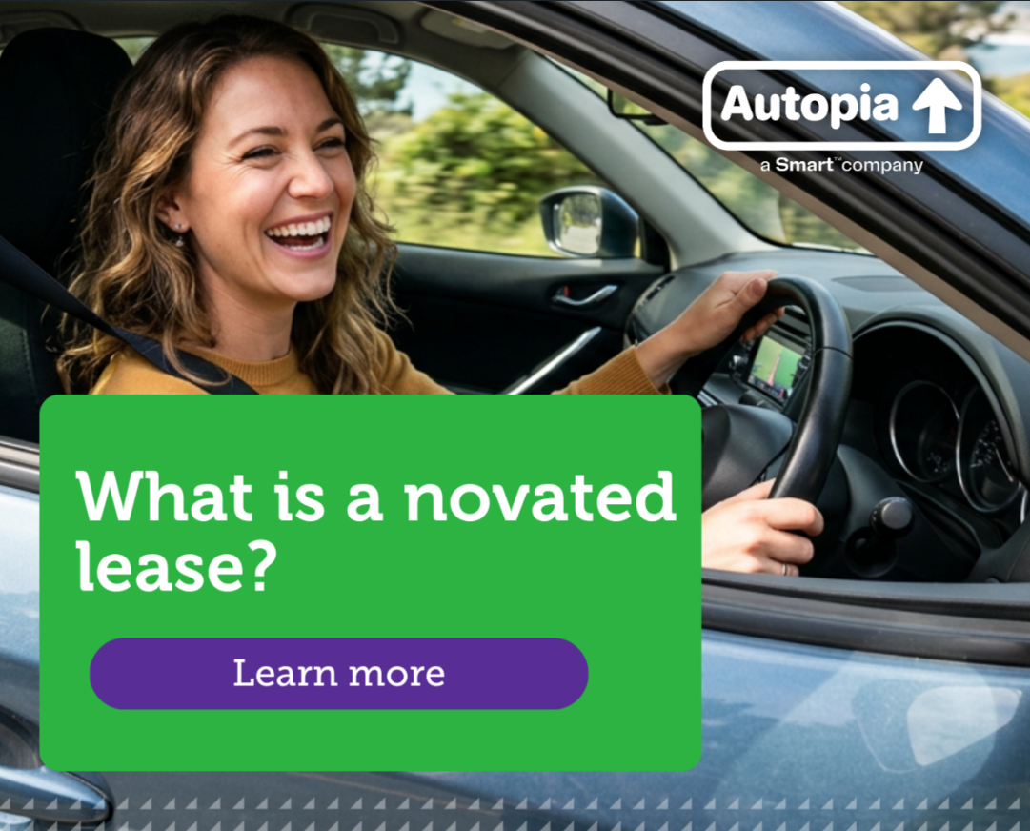
🚘 What is a novated lease?
A novated lease is a three-way agreement between you, us (your employer), and Autopia—allowing you to pay for your car and running costs from your salary.
✔ Combine car payments, fuel, rego & insurance
✔ Manage costs in a simple, bundled way
✔ Potential tax savings
👉 Learn more > Novated Leasing & Car Salary Packaging with Autopia

Post 3 – Book a Consultation (Image + Text)


📞 Thinking about your next car?
Get personalised advice from an Autopia leasing expert.
✔ Tailored quotes
✔ Support with choosing the right car
✔ Flexible appointment times
👉 Book a phone consultation

Post 4 – Drive Your Salary Further (Image + Text)

💰 Make your salary go further
Did you know a novated lease can be one of the most cost-effective ways to own and run a car?
You could benefit from:
- Potential tax savings
- Simplified budgeting
- Convenience of bundled costs
👉 Explore your options > Novated Leasing & Car Salary Packaging with Autopia

Post 5 – EV Opportunity (Image + Text)
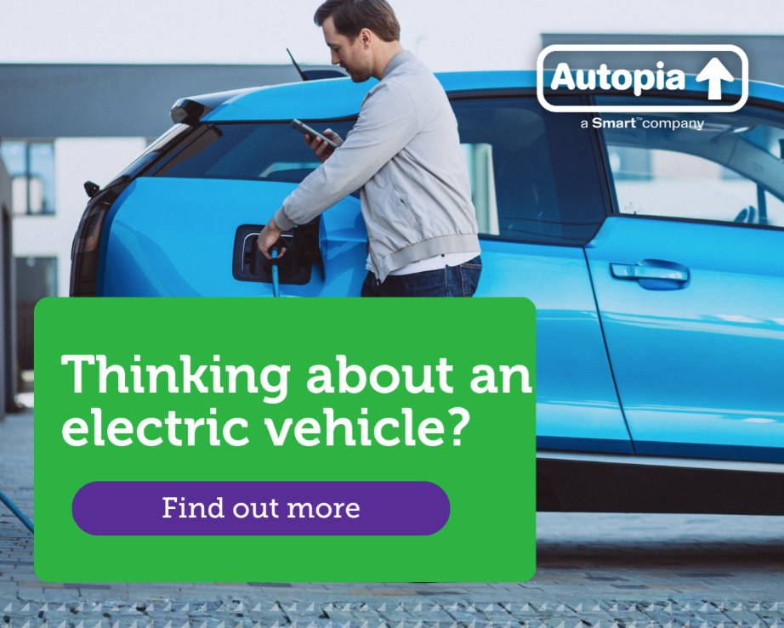
⚡ Thinking about an electric vehicle?
With government incentives, eligible EVs may be more affordable through a novated lease.
✔ Potential FBT savings
✔ Lower running costs
✔ Sustainable choice
👉 Find out more > Novated Leasing & Car Salary Packaging with Autopia

Post 6 – Webinar Invitation (Image + Text)
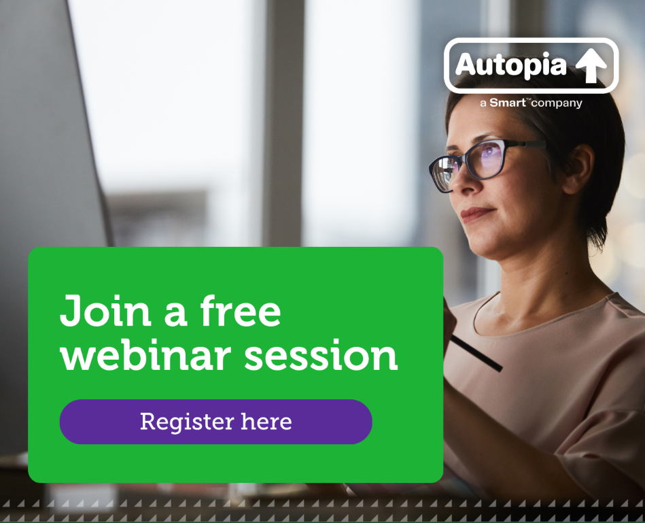

📅 Join a free Autopia information session
Want to understand how novated leasing works?
Autopia is hosting free online sessions to explain:
- How novated leasing works
- Potential savings
- EV opportunities
👉 Register here > globaleventregister
Sessions are general information only.

Post 7 – Lifestyle Flexibility (Image + Text)

👨‍👩‍👧 Designed for your lifestyle
Whether you're upgrading, going electric, or buying your first car—Autopia can help.
✔ Choose from new or used cars
✔ Include all running costs
✔ Speak to experts anytime
👉 Book a consultation

Post 8 – Convenience (Image + Text)

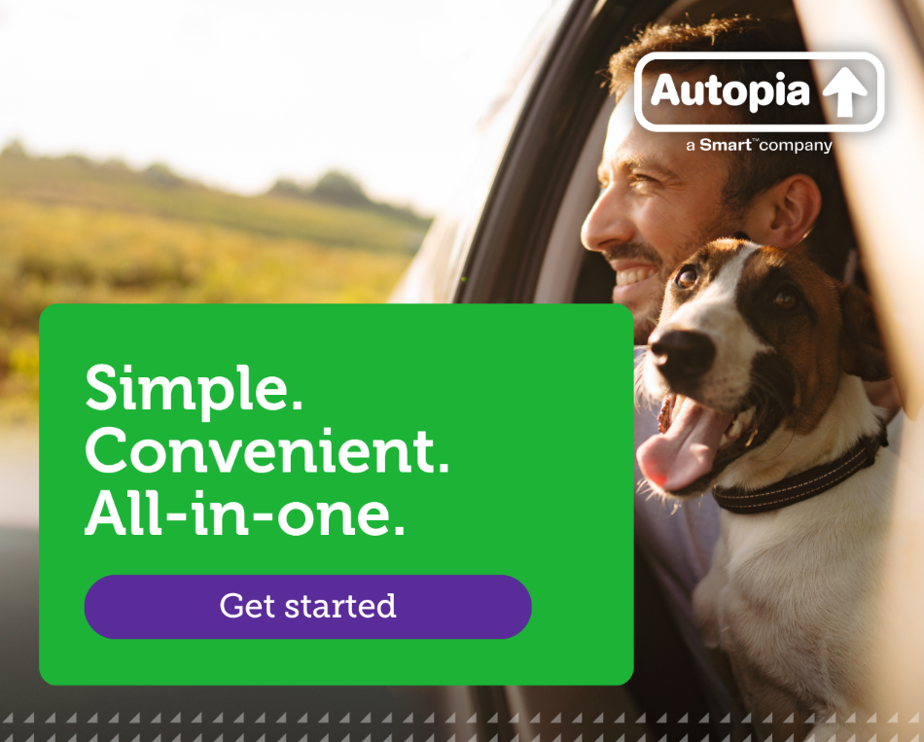

⏱ Simple. Convenient. All-in-one.
With a novated lease through Autopia:
- One regular payment covers your car and running costs
- No need to manage multiple bills
- Expert support along the way
👉 Get started > Novated Leasing & Car Salary Packaging with Autopia

Post 9 – Call to Action (Image + Text)


🚗 Ready to explore your options?
Now is a great time to see how novated leasing could work for you.
✔ Quick and easy process
✔ Personalised quotes
✔ No obligation to proceed
👉 Book your consultation today

Post 10 – Call to Action (Image + Text)

🚘 Drive your next car with Autopia
Salary packaging your car through a novated lease could help you:
- Save money
- Simplify your finances
- Access a wide range of vehicles
⚡ Including potential benefits for eligible electric vehicles
👉 Start your journey today

